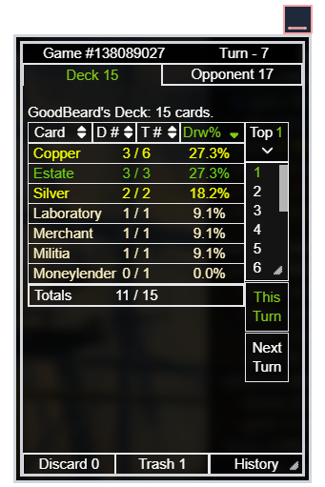

**D#** - This column shows the number of cards currently in the draw pile.

**T#** - This column shows the number of total cards in Deck (whether they are in play, in discard, in hand, etc).

**Drw%** - This column shows the probability of drawing one of the cards in the top N cards. (N can be selected by user to be any number, see ‘**Top #**’ below).

**Top #** - Select a number from the dropdown to display probabilities of drawing one of the cards in the next 1,2,3,4…. X cards.

**Opponent Tab** – Hover or click to view Opponent’s Deck.

**Discard Tab** – Hover or click to view the cards in your discard Pile.

**Trash Tab** – Hover or click to view cards trashed by each player.

**History Tab** – Opens link to view previously played matches while using the Dominion Companion.

**This Turn** – Hover or click to display draw probabilities for this turn (**will not** **include** cards that are currently set aside, in hand, or in play).

**Next Turn** – Hover or click to display draw probabilities for the next turn (**includes** cards that are currently set aside, in hand, or in play).

Reminder: The Dominion Companion is draggable, resizable, and minimizable.